Problem 1:……………………………………..(20 pts.)
- (10 pts.) Write a Verilog behavioral description (using always) of a four-bit adder module. The adder should have three inputs, a, b, and cin, and two outputs, sum and cout. Ports cin and cout are one bit, the other ports are four bits each.

module add4 (sum, cout, a, b, cin);

output [3:0] sum;
output cout;
input [3:0] a, b;
input cin;
//Write your code here
reg [3:0] sum;
reg cout;

always @( a or b or cin )
{cout, sum} = a + b + cin;

endmodule

- (10 pts.) Write a Verilog structural description (using hierarchical design methodology) of an eight-bit adder that uses two of the four-bit adders above. (That is, instantiate the module designed above.)

module add8 (sum, cout, a, b, cin);

output [7:0] sum;
output cout;
input [7:0] a, b;
input cin;
//Write your code here
wire cbetween;

add4 a1 (.sum(sum[3:0]), .cout(cbetween), .a(a[3:0]), .b(b[3:0]), .cin(cin));
add4 a2 (.sum(sum[7:4]), .cout(cout), .a(a[7:4]), .b(b[7:4]), .cin(cbetween));

endmodule
Problem 2:.…………………………………….(20 pts.)
Consider a two-bit comparator that has two inputs A and B and three outputs where the first output is asserted if A==B, second output is asserted if A>B and finally the last output is asserted if A<B.

- (10 pts.) Write a Verilog dataflow description (using assign) of a two-bit comparator module. The comparator should have two inputs, A and B, and three outputs, AEB (indicating A==B), AGB (indicating A>B) and ALB (indicating A<B). Ports AEB, AGB and ALB are one bit, the other ports are two bits each.

module comp2 (AEB, AGB, ALB, A, B);

output AEB, AGB, ALB;
input [1:0] A, B;
//Write your code here

assign AEB = A==B, AGB = A>B, ALB = A<B;

endmodule

- (10 pts.) Synthesize a combinational circuit that can compare two four-bit numbers A (=A₃A₂A₁A₀) and B (=B₃B₂B₁B₀) using hierarchical design approach, employing the above two-bit comparator as a building block. The hierarchical design of the four-bit comparator is provided in Figure 1.

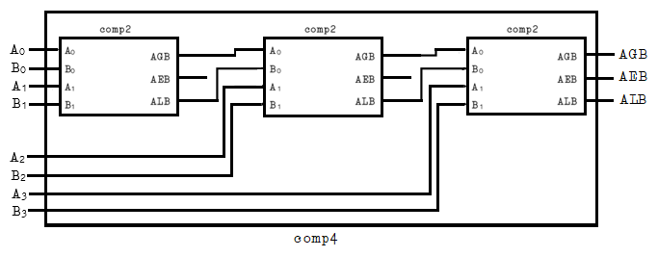
Figure 1. Hierarchical design of four-bit comparator
module comp4 (AEB, AGB, ALB, A, B);

output AEB, AGB, ALB;
input [3:0] A, B;
//Write your code here
wire AEB1, AGB1, ALB1, AEB2, AGB2, ALB2;

comp2 c1 (.AEB(AEB1), .AGB(AGB1), .ALB(ALB1), .A(A[1:0]), .B(B[1:0]));
comp2 c2 (.AEB(AEB2), .AGB(AGB2), .ALB(ALB2), .A({A[2], AGB1}), .B({B[2], ALB1}));
comp2 c3 (.AEB(AEB), .AGB(AGB), .ALB(ALB), .A({A[3], AGB2}), .B({B[3], AGB2}));

endmodule

Problem 3:.…………………………………….(30 pts.)
- (10 pts.) Figure 2 shows a 7-segment decoder that has a four-bit input ABCD (A is msb and D is lsb). This decoder produces seven outputs that are used to display a character on a 7-segment display. Table 1 lists the characters that should be displayed for each value of ABCD.

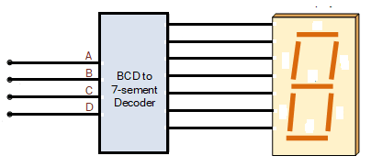
1
6
5
4
3
2c
0
5
0
6
4
3
2c
1
7-segment Decoder

Figure 2. A 7-segment Display and Decoder

The seven segments in the display are identified by the indices 0 to 6 as shown in the figure. Each segment is illuminated by driving it to the logic value 0. Write a Verilog module for the 7-segment decoder. Use any Verilog structure that makes sense to you.

ABCD | Character
0000 | H
0001 | E
0010 | L
0011 | L
0100 | O
0101 | H
0110 | E
0111 | L
1000 | P
1001 | P
1010 | L
1011 | E
1100 | A
1101 | S
1110 | E
1111 | -

Table 1. Character Code Table

module segment7 (seg, A, B, C, D);
output [0:6] seg;
input A, B, C, D;
//Write your code here
reg [0:6] seg;

/*always block for converting ABCD digit into 7 segment format*/
always @( A, B, C, D )
begin
case ({A, B, C, D}) //case statement
4’d0: seg = 7'b1001000; //H
4’d1: seg = 7'b0110000; //E
4’d2: seg = 7'b1110001; //L
4’d3: seg = 7'b1110001; //L
4’d4: seg = 7'b0000001; //O
4’d5: seg = 7'b1001000; //H
4’d6: seg = 7'b0110000; //E
4’d7: seg = 7'b1110001; //L
4’d8: seg = 7'b0011000; //P
4’d9: seg = 7'b0011000; //P
4’d10: seg = 7'b1110001; //L
4’d11: seg = 7'b0110000; //E
4’d12: seg = 7'b0001000; //A
4’d13: seg = 7'b0100100; //S
4’d14: seg = 7'b0110000; //E
4’d15: seg = 7'b1111110; //-

/*switch off 7 segment character when input is not a decimal number from 0 to 15.*/
default: seg = 7'b1111111;
endcase
end

endmodule

- (10 pts.) Write a Verilog module for a 4-bit negative-edge triggered up counter with asynchronous clear.

module counter (count, clk, clr);
output [3:0] count;
input clk, clr;
//Write your code here
reg [3:0] count;

always @( negedge clk or posedge clr )
begin
if (clr)
count = 4'b0000;
else
count = count + 1'b1;
end

endmodule

- (10 pts.) In this problem, write a top-level module that combines the 7-segment decoder (from 3(a)) with the counter (from 3(b)) to create a circuit such that the output of the counter controls the input lines of the decoder.

The suggested skeleton file has been written below.

module Top (out, clk, rst);

output [0:6] out;
input clk, rst;
//Write your code here
wire [3:0] tmp;

counter c (.count(tmp), .clk(clk), .clr(rst));
segment7 s7 (.seg(out), .A(temp[3]), .B(temp[2]), .C(temp[1]), .D(temp[0]));

endmodule

